BAB I
PENDAHULUAN

Video provides a powerful way to help you prove your point. When you click Online Video, you can paste in the embed code for the video you want to add. You can also type a keyword to search online for the video that best fits your document.

- Tujuan
Video provides a powerful way to help you prove your point. When you click Online Video, you can paste in the embed code for the video you want to add. You can also type a keyword to search online for the video that best fits your document.

- Ruang Lingkup
Video provides a powerful way to help you prove your point. When you click Online Video, you can paste in the embed code for the video you want to add. You can also type a keyword to search online for the video that best fits your document.
To make your document look professionally produced, Word provides header, footer, cover page, and text box designs that complement each other. For example, you can add a matching cover page, header, and sidebar. Click Insert and then choose the elements you want from the different galleries.
Themes and styles also help keep your document coordinated. When you click Design and choose a new Theme, the pictures, charts, and SmartArt graphics change to match your new theme. When you apply styles, your headings change to match the new theme.
Save time in Word with new buttons that show up where you need them. To change the way a picture fits in your document, click it and a button for layout options appears next to it. When you work on a table, click where you want to add a row or a column, and then click the plus sign.
Reading is easier, too, in the new Reading view. You can collapse parts of the document and focus on the text you want. If you need to stop reading before you reach the end, Word remembers where you left off - even on another device.

- Sistematika Pembahasan
Video provides a powerful way to help you prove your point. When you click Online Video, you can paste in the embed code for the video you want to add. You can also type a keyword to search online for the video that best fits your document.
- BAB I : PENDAHULUAN
Video provides a powerful way to help you prove your point. When you click Online Video, you can paste in the embed code for the video you want to add. You can also type a keyword to search online for the video that best fits your document.
- BAB II : TEORI PENUNJANG
Video provides a powerful way to help you prove your point. When you click Online Video, you can paste in the embed code for the video you want to add. You can also type a keyword to search online for the video that best fits your document.

BAB II
TEORI PENUNJANG

Video provides a powerful way to help you prove your point. When you click Online Video, you can paste in the embed code for the video you want to add. You can also type a keyword to search online for the video that best fits your document.

- HTML 5
Video provides a powerful way to help you prove your point. When you click Online Video, you can paste in the embed code for the video you want to add. You can also type a keyword to search online for the video that best fits your document.
To make your document look professionally produced, Word provides header, footer, cover page, and text box designs that complement each other. For example, you can add a matching cover page, header, and sidebar. Click Insert and then choose the elements you want from the different galleries.

- Canvas
Video provides a powerful way to help you prove your point. When you click Online Video, you can paste in the embed code for the video you want to add. You can also type a keyword to search online for the video that best fits your document.
Video provides a powerful way to help you prove your point. When you click Online Video, you can paste in the embed code for the video you want to add. You can also type a keyword to search online for the video that best fits your document.
To make your document look professionally produced, Word provides header, footer, cover page, and text box designs that complement each other. For example, you can add a matching cover page, header, and sidebar. Click Insert and then choose the elements you want from the different galleries.
Themes and styles also help keep your document coordinated. When you click Design and choose a new Theme, the pictures, charts, and SmartArt graphics change to match your new theme. When you apply styles, your headings change to match the new theme.


Gambar 2.1
Posisi Logo ISTTS di antara Paragraf

Video provides a powerful way to help you prove your point. When you click Online Video, you can paste in the embed code for the video you want to add. You can also type a keyword to search online for the video that best fits your document.
To make your document look professionally produced, Word provides header, footer, cover page, and text box designs that complement each other. For example, you can add a matching cover page, header, and sidebar. Click Insert and then choose the elements you want from the different galleries.
Themes and styles also help keep your document coordinated. When you click Design and choose a new Theme, the pictures, charts, and SmartArt graphics change to match your new theme. When you apply styles, your headings change to match the new theme.
To make your document look professionally produced, Word provides header, footer, cover page, and text box designs that complement each other. For example, you can add a matching cover page, header, and sidebar. Click Insert and then choose the elements you want from the different galleries.
- Type of Canvas
Video provides a powerful way to help you prove your point. When you click Online Video, you can paste in the embed code for the video you want to add. You can also type a keyword to search online for the video that best fits your document. To make your document look professionally produced, Word provides header, footer, cover page, and text box designs that complement each other.

  - Video
Video provides a powerful way to help you prove your point. When you click Online Video, you can paste in the embed code for the video you want to add. You can also type a keyword to search online for the video that best fits your document.
- Video provides a powerful way to help you prove your point. When you click Online Video, you can paste in the embed code for the video you want to add. You can also type a keyword to search online for the video that best fits your document.


Gambar 2.2
Posisi Logo ISTTS Kuning Milik Poin a

- To make your document look professionally produced, Word provides header, footer, cover page, and text box designs that complement each other.
  - Video provides a powerful way to help you prove your point. When you click Online Video, paste in the embed code for the video you want to add.
  - When you apply styles, your headings change to match the new theme.


Gambar 2.3
Posisi Potret Elang Milik Poin b-2

Video provides a powerful way to help you prove your point. When you click Online Video, you can paste in the embed code for the video you want to add. You can also type a keyword to search online for the video that best fits your document.

- 3D
Video provides a powerful way to help you prove your point. When you click Online Video, you can paste in the embed code for the video you want to add. You can also type a keyword to search online for the video that best fits your document.
- To make your document look professionally produced, Word provides header, footer, cover page, and text box designs that complement each other. Click Insert and then choose the elements you want from the different galleries. When you click Design and choose a new Theme, the pictures, charts, and SmartArt graphics change to match your new theme. When you apply styles, your headings change to match the new theme.
Tabel 2.1
Contoh Data Kode dan Nama Program Studi ISTTS –Tabel Milik Subbab 2.1.2 Poin a
No | Kode | Nama
1 | 01 | D3-Informatika
2 | 10 | S1-Elektro
3 | 11 | S1-Informatika
4 | 12 | S1-Industri
5 | 18 | S1-Sistem Informasi
6 | 17 | S1-Design Komunikasi Visual
7 | 21 | S2-Teknologi Informasi

- Video provides a powerful way to help you prove your point. When you click Online Video, you can paste in the embed code for the video you want to add. You can also type a keyword to search online for the video that best fits your document.

- Kinnect II
Video provides a powerful way to help you prove your point. When you click Online Video, you can paste in the embed code for the video you want to add. You can also type a keyword to search online for the video that best fits your document.
To make your document look professionally produced, Word provides header, footer, cover page, and text box designs that complement each other. For example, you can add a matching cover page, header, and sidebar. Click Insert and then choose the elements you want from the different galleries. Themes and styles also help keep your document coordinated.

Tabel 2.2
Organisasi Kampus
No | Nama
1 | Badan Eksekutif Mahasiswa
2 | Himpunan Mahasiswa
3 | Unit Kegiatan Mahasiswa
4 | Unit Kegiatan Kerohanian
5 | Panitia PK
6 | Panitia Kartini Day
Tabel 2.2
(Lanjutan)
No | Nama
7 | Panitia Dies Natalis
8 | Panitia Baksos
9 | Panitia Bunkasai

Video provides a powerful way to help you prove your point. When you click Online Video, you can paste in the embed code for the video you want to add. You can also type a keyword to search online for the video that best fits your document.
To make your document look professionally produced, Word provides header, footer, cover page, and text box designs that complement each other. For example, you can add a matching cover page, header, and sidebar. Click Insert and then choose the elements you want from the different galleries.

Video provides a powerful way to help you prove your point. When you click Online Video, you can paste in the embed code for the video you want to add. You can also type a keyword to search online for the video that best fits your document.

Themes and styles also help keep your document coordinated. When you click Design and choose a new Theme, the pictures, charts, and SmartArt graphics change to match your new theme. When you apply styles, your headings change to match the new theme.

To make your document look professionally produced, Word provides header, footer, cover page, and text box designs that complement each other. For example, you can add a matching cover page, header, and sidebar. Click Insert and then choose the elements you want from the different galleries.

Themes and styles also help keep your document coordinated. When you click Design and choose a new Theme, the pictures, charts, and SmartArt graphics change to match your new theme. When you apply styles, your headings change to match the new theme.

Video provides a powerful way to help you prove your point. When you click Online Video, you can paste in the embed code for the video you want to add. You can also type a keyword to search online for the video that best fits your document.
To make your document look professionally produced, Word provides header, footer, cover page, and text box designs that complement each other. For example, you can add a matching cover page, header, and sidebar. Click Insert and then choose the elements you want from the different galleries. (Busby, et al., 2010)
Themes and styles also help keep your document coordinated. When you click Design and choose a new Theme, the pictures, charts, and SmartArt graphics change to match your new theme. When you apply styles, your headings change to match the new theme.

- Virtual Reality
Video provides a powerful way to help you prove your point. When you click Online Video, you can paste in the embed code for the video you want to add. You can also type a keyword to search online for the video that best fits your document.
To make your document look professionally produced, Word provides header, footer, cover page, and text box designs that complement each other. For example, you can add a matching cover page, header, and sidebar. Click Insert and then choose the elements you want from the different galleries.
Themes and styles also help keep your document coordinated. When you click Design and choose a new Theme, the pictures, charts, and SmartArt graphics change to match your new theme. When you apply styles, your headings change to match the new theme.

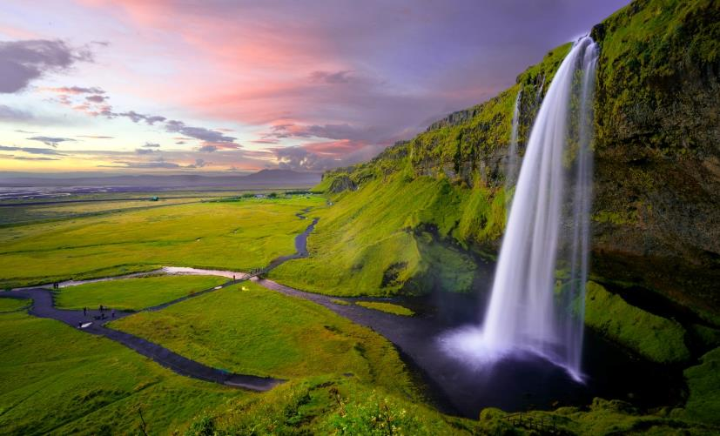
(a)
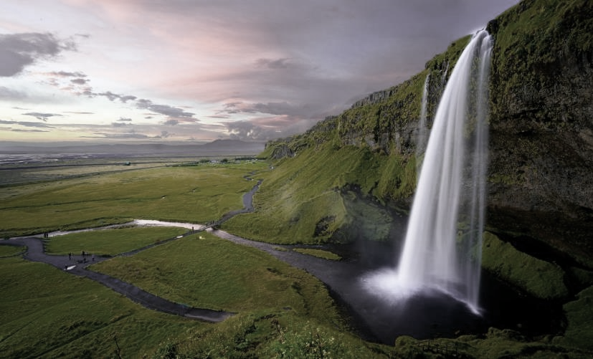
(b)
Gambar 2.4
Waterfall (a) Waterfall Normal. (b) Setelah Diberi Filter

Themes and styles also help keep your document coordinated. When you click Design and choose a new Theme, the pictures, charts, and SmartArt graphics change to match your new theme. When you apply styles, your headings change to match the new theme.
BAB III
SISTEM DESAIN

Video provides a powerful way to help you prove your point. When you click Online Video, you can paste in the embed code for the video you want to add. You can also type a keyword to search online for the video that best fits your document.
To make your document look professionally produced, Word provides header, footer, cover page, and text box designs that complement each other. For example, you can add a matching cover page, header, and sidebar. Click Insert and then choose the elements you want from the different galleries.

- Desain Interface
Video provides a powerful way to help you prove your point. When you click Online Video, you can paste in the embed code for the video you want to add. You can also type a keyword to search online for the video that best fits your document.
To make your document look professionally produced, Word provides header, footer, cover page, and text box designs that complement each other. For example, you can add a matching cover page, header, and sidebar. Click Insert and then choose the elements you want from the different galleries.
Themes and styles also help keep your document coordinated. When you click Design and choose a new Theme, the pictures, charts, and SmartArt graphics change to match your new theme. When you apply styles, your headings change to match the new theme :
- Xbanner
- Outdoor banner
- Rollup Banner
Save time in Word with new buttons that show up where you need them. To change the way a picture fits in your document, click it and a button for layout options appears next to it. When you work on a table, click where you want to add a row or a column, and then click the plus sign.
Reading is easier, too, in the new Reading view. You can collapse parts of the document and focus on the text you want. If you need to stop reading before you reach the end, Word remembers where you left off - even on another device.

- Layout Booklet
Video provides a powerful way to help you prove your point. When you click Online Video, you can paste in the embed code for the video you want to add. You can also type a keyword to search online for the video that best fits your document.


(a) (b)
Gambar 3.1
Potret Elang (a) Elang Normal. (b) Setelah Diberi Filter

To make your document look professionally produced, Word provides header, footer, cover page, and text box designs that complement each other. For example, you can add a matching cover page, header, and sidebar. Click Insert and then choose the elements you want from the different galleries.

- X-Banner
Video provides a powerful way to help you prove your point. When you click Online Video, you can paste in the embed code for the video you want to add. You can also type a keyword to search online for the video that best fits your document.
To make your document look professionally produced, Word provides header, footer, cover page, and text box designs that complement each other. For example, you can add a matching cover page, header, and sidebar. Click Insert and then choose the elements you want from the different galleries.
Themes and styles also help keep your document coordinated. When you click Design and choose a new Theme, the pictures, charts, and SmartArt graphics change to match your new theme. When you apply styles, your headings change to match the new theme.
Save time in Word with new buttons that show up where you need them. To change the way a picture fits in your document, click it and a button for layout options appears next to it. When you work on a table, click where you want to add a row or a column, and then click the plus sign.


(a) (b)

(c) (d)
Gambar 3.2
Potret Elang (a) Elang Normal. (b) Setelah Diberi Filter BW. (c) Filter Kuning. (d) Filter Hijau

To make your document look professionally produced, Word provides header, footer, cover page, and text box designs that complement each other. For example, you can add a matching cover page, header, and sidebar. Click Insert and then choose the elements you want from the different galleries.

- Desain Database
Video provides a powerful way to help you prove your point. When you click Online Video, you can paste in the embed code for the video you want to add. You can also type a keyword to search online for the video that best fits your document.
To make your document look professionally produced, Word provides header, footer, cover page, and text box designs that complement each other. For example, you can add a matching cover page, header, and sidebar. Click Insert and then choose the elements you want from the different galleries.
Themes and styles also help keep your document coordinated. When you click Design and choose a new Theme, the pictures, charts, and SmartArt graphics change to match your new theme. When you apply styles, your headings change to match the new theme.

- Desain Procedural
Video provides a powerful way to help you prove your point. When you click Online Video, you can paste in the embed code for the video you want to add. You can also type a keyword to search online for the video that best fits your document.
To make your document look professionally produced, Word provides header, footer, cover page, and text box designs that complement each other. For example, you can add a matching cover page, header, and sidebar. Click Insert and then choose the elements you want from the different galleries.

Algoritma 3.1 Contoh Algoritma Cek Prima
- SREAD N
- C = 0
- FOR I = 2 TO N-1
- IF N mod I = 0
- C = C + 1
- END IF
Algoritma 3.1 (Lanjutan)
- END FOR
- IF C = 0
- WRITE “PRIMA”
- ELSE
- WRITE “BUKAN PRIMA”
- END IF

Video provides a powerful way to help you prove your point. When you click Online Video, you can paste in the embed code for the video you want to add. You can also type a keyword to search online for the video that best fits your document.
To make your document look professionally produced, Word provides header, footer, cover page, and text box designs that complement each other. For example, you can add a matching cover page, header, and sidebar. Click Insert and then choose the elements you want from the different galleries.

Algoritma 3.2 Contoh Algoritma Membedakan Ganjil dan Genap
- Read N
- IF N mod 2 = 1 THEN
- A = GANJIL
- ELSE
- A = GENAP
- END IF
- WRITE A

Video provides a powerful way to help you prove your point. When you click Online Video, you can paste in the embed code for the video you want to add. You can also type a keyword to search online for the video that best fits your document.
To make your document look professionally produced, Word provides header, footer, cover page, and text box designs that complement each other. For example, you can add a matching cover page, header, and sidebar. Click Insert and then choose the elements you want from the different galleries.

L = s x s (3.1)

Video provides a powerful way to help you prove your point. When you click Online Video, you can paste in the embed code for the video you want to add. You can also type a keyword to search online for the video that best fits your document.
To make your document look professionally produced, Word provides header, footer, cover page, and text box designs that complement each other. For example, you can add a matching cover page, header, and sidebar. Click Insert and then choose the elements you want from the different galleries.

$z_{t}=tanh⁡({U^{z} . h}_{t-1}+ x_{t} . W^{z}+ b^{z})$ (3.2)
$i_{t}= σ({U^{i} . h}_{t-1}+ x_{t} . W^{i}+ b^{i})$ (3.3)
$i_{0}= σ(W^{i} . x_{0} + {U^{i} . h}_{-1}+ b^{i})$ (3.4)
$$=σ\left( \left[\begin{matrix}1 & 1 & 1 & 1 & 1 \\ 1 & 1 & 1 & 1 & 1 \\ 1 & 1 & 1 & 1 & 1 \\ 1 & 1 & 1 & 1 & 1 \\ 1 & 1 & 1 & 1 & 1\end{matrix}\right] \left[\begin{matrix}1 \\ 0 \\ 0 \\ 0 \\ 0\end{matrix}\right]+\left[\begin{matrix}1 & 1 & 1 & 1 & 1 \\ 1 & 1 & 1 & 1 & 1 \\ 1 & 1 & 1 & 1 & 1 \\ 1 & 1 & 1 & 1 & 1 \\ 1 & 1 & 1 & 1 & 1\end{matrix}\right] \left[\begin{matrix}0 \\ 0 \\ 0 \\ 0 \\ 0\end{matrix}\right]+\left[\begin{matrix}1 \\ 1 \\ 1 \\ 1 \\ 1\end{matrix}\right] \right)$$
$$=σ\left( \left[\begin{matrix}1 \\ 1 \\ 1 \\ 1 \\ 1\end{matrix}\right]+ \left[\begin{matrix}0 \\ 0 \\ 0 \\ 0 \\ 0\end{matrix}\right]+\left[\begin{matrix}1 \\ 1 \\ 1 \\ 1 \\ 1\end{matrix}\right] \right)=σ\left( \left[\begin{matrix}2 \\ 2 \\ 2 \\ 2 \\ 2\end{matrix}\right] \right)= \left[\begin{matrix}0.88 \\ 0.88 \\ 0.88 \\ 0.88 \\ 0.88\end{matrix}\right]$$

Keliling = 4 x s (3.5)

Video provides a powerful way to help you prove your point. When you click Online Video, you can paste in the embed code for the video you want to add. You can also type a keyword to search online for the video that best fits your document.

BAB IV
IMPLEMENTASI

Video provides a powerful way to help you prove your point. When you click Online Video, you can paste in the embed code for the video you want to add. You can also type a keyword to search online for the video that best fits your document.
To make your document look professionally produced, Word provides header, footer, cover page, and text box designs that complement each other. For example, you can add a matching cover page, header, and sidebar. Click Insert and then choose the elements you want from the different galleries.

Segmen Program 4.1 Contoh Program Membedakan Ganjil dan Genap
- int i;
- cin >> i;
- if (i % 2 == 0)
- {
- cout << “GENAP”;
- }
- else
- {
- cout << “GANJIL”;
- }

Video provides a powerful way to help you prove your point. When you click Online Video, you can paste in the embed code for the video you want to add. You can also type a keyword to search online for the video that best fits your document. To make your document look professionally produced, Word provides header, footer, cover page, and text box designs that complement each other. For example, you can add a matching cover page, header, and sidebar. Click Insert and then choose the elements you want from the different galleries.

Segmen Program 4.2 Required Field
- <?php
// define variables and set to empty values
- $nameErr = $emailErr = $genderErr = $websiteErr = "";
- $name = $email = $gender = $comment = $website = "";
Segmen Program 4.2 (Lanjutan)
- if ($_SERVER["REQUEST_METHOD"] == "POST") {
- if (empty($_POST["name"])) {
- $nameErr = "Name is required";
- } else {
- $name = test_input($_POST["name"]);}

Video provides a powerful way to help you prove your point. When you click Online Video, you can paste in the embed code for the video you want to add. You can also type a keyword to search online for the video that best fits your document.
To make your document look professionally produced, Word provides header, footer, cover page, and text box designs that complement each other. For example, you can add a matching cover page, header, and sidebar. Click Insert and then choose the elements you want from the different galleries.

Chairil Anwar, Deru Campur Debu, (Jakarta: PT GRAMEDIA PUSTAKA UTAMA, 1992), hlm 9.
Abdul Khalik, Rapi Armad, Bagus Kuncoro, Belajar Bahasa Indonesia, (Surabaya: Dwikarya, 2009), hlm 25.
Mc. Preganent, Representative of Natural Habits with Prulal Educaton. Educational Evaluation and Alanytics. Vol. 4 No. 3, Summer 2003, hlm. 120
Richard Whittle, High Sea Piracy: Crisis in Aden (http://www.aviationtoday.com/rw/military/attack/High-Sea-Piracy-Crisis-in-Aden_32500.html, diakses pada tanggal 31 Mei 2013)

